**EXTRACTING WATER BODIES FROM NAGPUR CITY’S MAP**

Below is the given algorithm,how we can extract water bodies from an old Nagpur map and reproject it on a recent map.

**Given:**

1)Old nagpur image (1857)

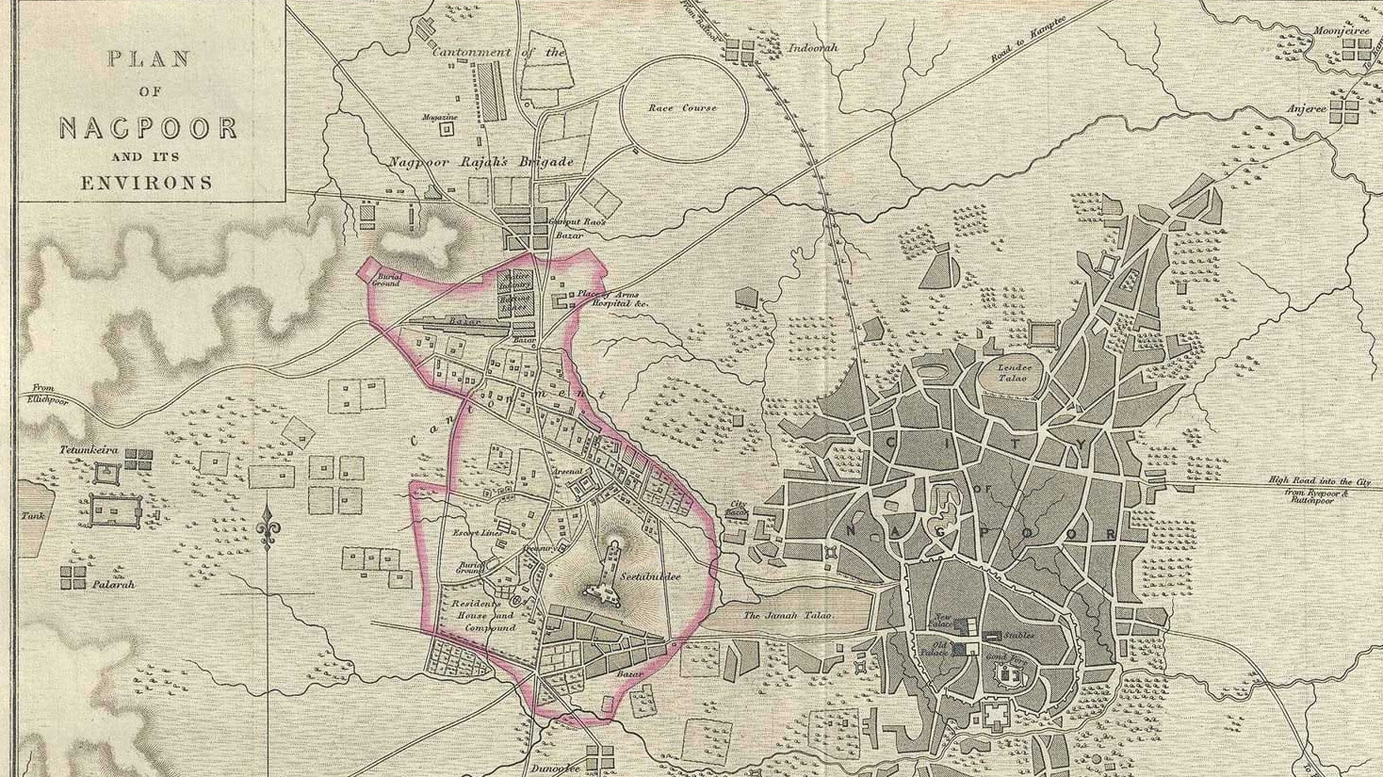

**Step to achieve the output**

Step 1:-Paint the water bodies to colour blue.

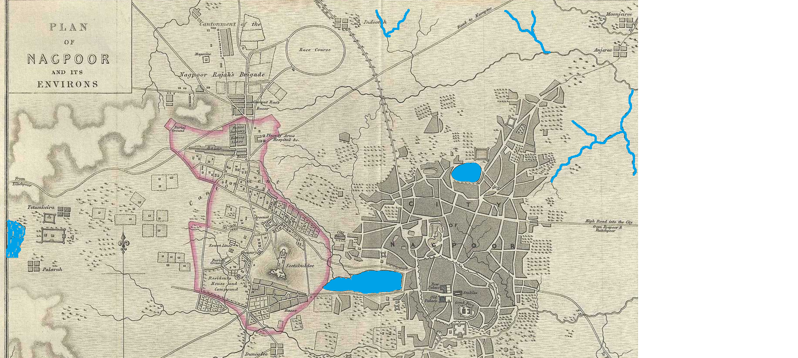

Step 2:-Open QGIS and convert this png file to geotiff file

(A GeoTIFF is an image file with embedded geographic coordinates, enabling accurate mapping and spatial analysis.)

Step 3:Now using python we will extract the blue water bodies from the geotiff image.

Note:Check the crs of the image.It should be in lat long crs i.e. **EPSG:4326** or **WGS 84**

Step 4:If the image is not in **EPSG:4326** or **WGS 84** ,we need to reproject the geotiff image.

Step 5: Start with importing libraries

import cv2

import numpy

import json

import rasterio

from osgeo import osr

from matplotlib import pyplot

Step 6: Load the Reprojected geotiff image.

Step 7:To extract the blue bodies from the a geotiff image,we need to first vectorize it,which means we need to extract only the blue bodies from the image ,as shown below

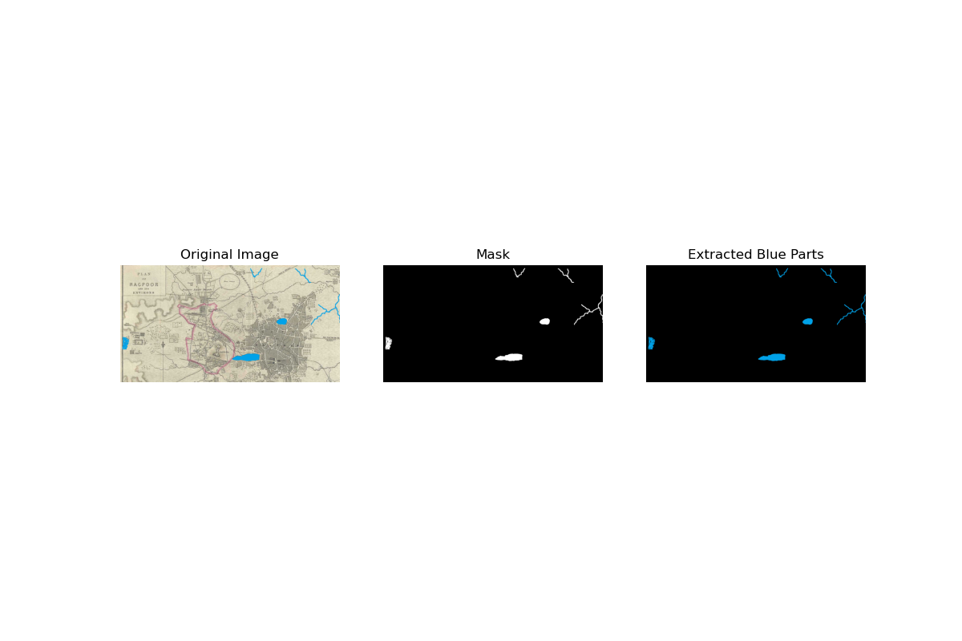Step 8:How will we extract the blue part?

1.Color range:Give the required threshold to the image.

2.Create mask:If the image falls in the given colour ranges,it extracts the blue bodies.

3.Gives the final extracted blue region.

4.Contouring:Extracts the outlining of the blue bodies.

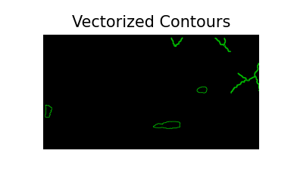

Step 9:Now open the reprojected Geotiff image to extract geographic transform using rasterio.open()

Step 10:Convert the contours to Geojson

* **osr.SpatialReference()** creates an object that handles information about the map's coordinate system (how the map data is aligned on the earth).
* **src.crs.to_wkt()** gets the map's coordinate system details from the file in a text format.
* **ImportFromWkt()** tells the spatial reference object to use those details.

This step ensures that the image’s coordinates (latitude/longitude) are correctly interpreted.

Step 11:Create JSON features

Step 12:Save this the a Json file

Step 13:At last if you want to visualise the output,add python code for visualisation.

**OUTPUT:**